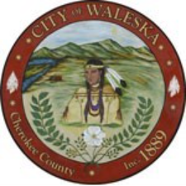
CITY OF WALESKA
Regular Meeting of the Mayor and Council
8891 Fincher Rd.
Waleska, Ga 30183
October 19, 2026
6:30 p.m.

Item 1: Call to Order
Item 2: Invocation / Pledge of Allegiance
Item 3: Consideration to Approve the Regular Meeting Minutes from October 5, 2026
Item 4: Five Minute Public Input
Item 5: Consideration to Adopt the Amendment to the City of Waleska Street Lighting Ordinance
Item 6: First Reading – Ordinance Amending Chapter 2, Article V, Purchasing
Item 7: Consideration and Possible Adoption of City Vehicle and Equipment Use Policy
Item 8: Consideration and Possible Approval of Alcohol Beverage License – Milpas Cocina, 6874 Reinhardt College Parkway
Item 9: Discussion for GDOT Proposed Roundabout at SR 140 and SR 108
Item 10: Water System Report
Item 11: City Clerk’s Report
Item 12: City Attorney’s Report
Item 13: Mayor’s Report
Item 14: Council Remarks
Item 15: Recess Regular Meeting for Executive Session
Item 16: Reconvene Regular Meeting
Item 17: Adjournment of Regular Council Meeting

